Transformations Study Guide Key
1. | A
2. | C
3. | D
4. | B
5. | F’ (3, -4); G’ (0, -6); H’ (1, -1)
6. | B
7. | C
8. | (2, -2) or 2 right, 2 down
9. | 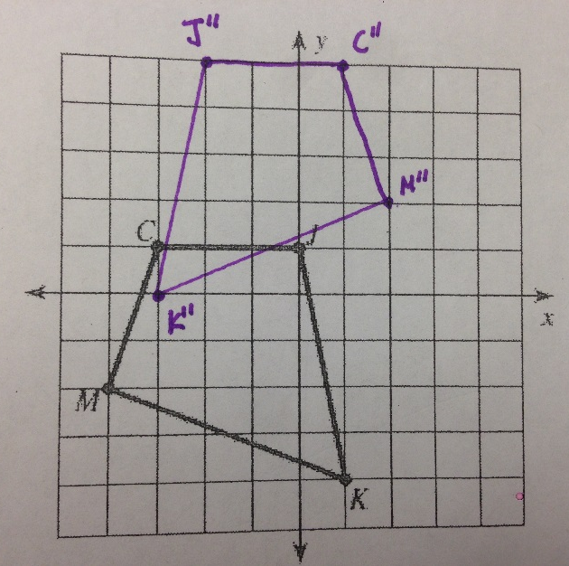
10. | 