Proportions/Ratios on the Coordinate Plane TOC # _____
Math 6-Unit 2 MCC6.RP.3, 3a

Part 1: Let’s look at the relationship between cups and pints. We know that the ratio of cups to pints is 2 : 1. Complete the missing values in the table.

X  (cups) | Y  (pints) | (x, y)
2 | 1
4 | 2
6 | 3
8 | 4
___ | 5
12 | ___

Graph the ordered pairs from the table. Because the table is proportional, the graph should be a straight line. Check to see that the table and the graphed line are both showing the same proportional relationship.
Cups vs. Pints
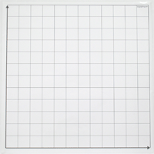
Pints (y-axis)

Cups (x-axis)
Part 2: Create your own proportional relationship in the table below. Then graph the relationship on the coordinate plane. Make sure that you include the following:
- A title.
- Your x-axis and y-axis should be labeled appropriately.
- You need correct intervals for both axes.

X  _________ | Y  ________ | (x, y)

__________________________________________

