MATH 7 Study Guide Name
Unit 3 Ratios and Proportional Relationships Date Per

Knowledge and Understanding

- How is unit rate used in everyday life?

- How can you determine if a relationship is proportional?

- A 68-ounce bottle of apple juice costs $4.08. Find the unit price. (Correctly label your answer.)

- Does the following table represent a proportional relationship? Justify your answer.

x | 2 | 4 | 6 | 8
y | 7.5 | 15 | 22.5 | 30

- Determine the constant of proportionality in the table below.
x | 6 | 7 | 9 | 13
y | 3.6 | 4.2 | 5.4 | 7.8

- Find 115% of 92.

Equation or proportion:

Solution:

- On a map, 1 cm represents 25 miles. Find the actual distance between two cities if they are
12.2 cm apart on the map.

- Jesse drove 34 miles in 20 minutes. If he drove at a constant rate, what is his speed in miles per hour?

- Mrs. Keel divided a bag of 48 questions between 2 students. The first student received
4 questions for every 8 questions that the second student received. How many questions did the second student receive? (Show your work/problem solving).

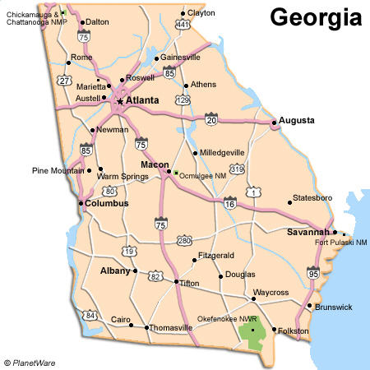
- The scale used on this map is 1 cm: 50 miles. If the distance between Atlanta and Brunswick is
307 miles, how many centimeters apart are the cities on this map?

- Miss Dawson has 140 students in her social studies classes. 80% of the students have completed their project. Of the remaining students, 25% have completed part of their project. How many of the remaining students have completed part of their project?

- Using the graph below, write the equation that shows the relationship between the number of pounds and the price.
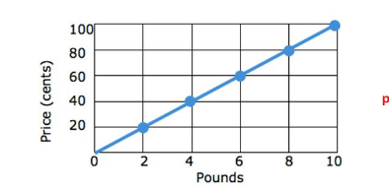

- Steven received a 6% commission on his total amount of sales. If his commission was $336.00, what was Steven’s total amount of sales?

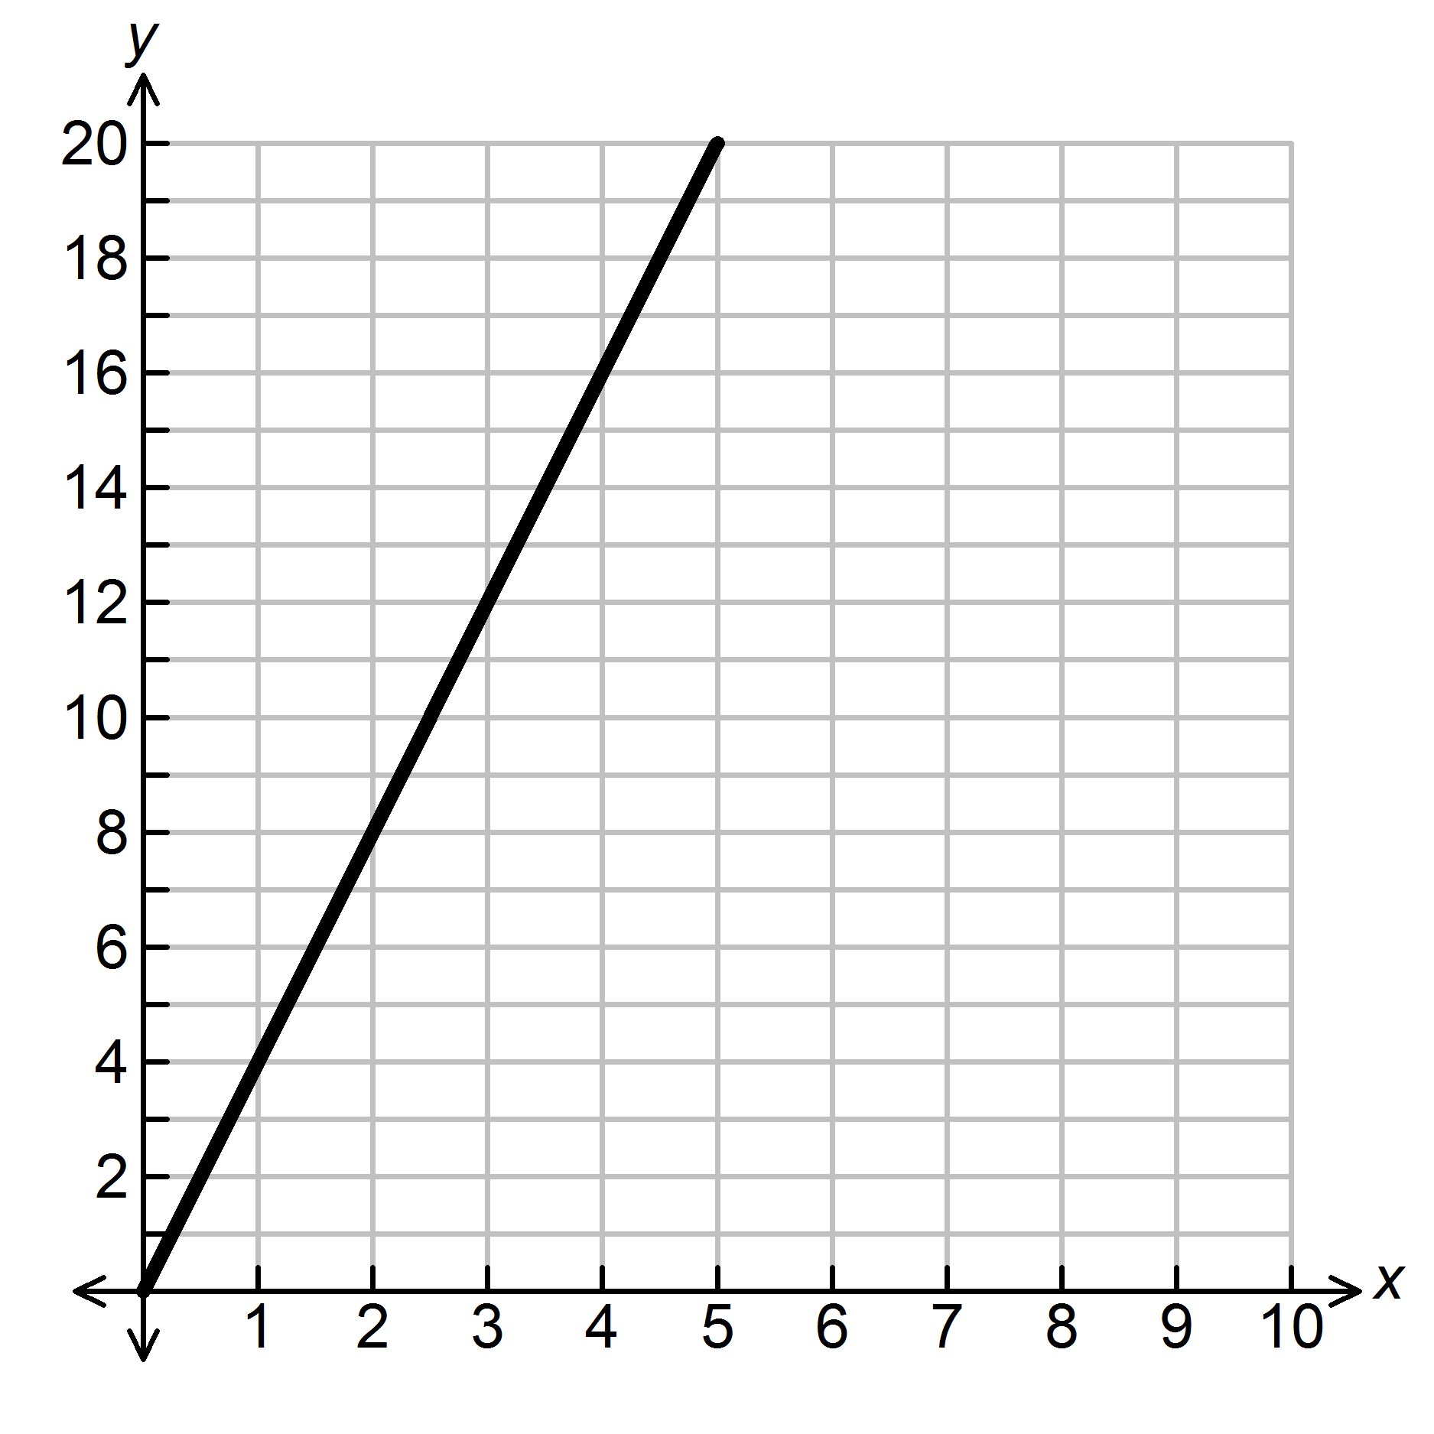
- The graph below shows the relationship between the amount of pay in x hours.
Explain what the ordered pair (2, 8) represents.

Pay in Dollars

hours

- There are 2 batches of lemonade. The first glass was made with 6 tablespoons of lemon and 4 cups of sugar water. The second glass was made with 7 tablespoons of lemon and 5 cups of sugar water. Which glass has a higher concentration of lemon? Why?

- TV’s at Best Buy are discounted 25%. If the tax rate is 7%, how much will a $1200 TV from Best Buy cost? (Show all work and circle your final answer).

- On a farm, 612 trees are being planted in rows. If the number of trees are the same in each row and there are thirty-six rows, write an equation that could be used to show the number of trees in each row.

- The ratio of boys to girls at a school carnival is 5:3. If 160 students attend the carnival, how many are boys and how many are girls? Explain how you know.

- A model of a drone has a scale of 1 cm = 7 inches. If the actual length of the drone is 84 inches, what is the model’s length?

20. You are working for an interior decorator. He would like to purchase carpet for the floor plan shown in the scale drawing below. Using the scale factor, find the number of square feet of carpet needed to cover the floor. Show all work.

Scale
1 cm: 4 feet
15 cm
9 cm
6 cm
6 cm
9 cm
15 cm

