**Math 6** Name ___________________________________  
**Unit 5: Area & Volume** Date _______________  
**Prerequisite Skills Pretest**

1. Simplify: ½ (4)(3)
2. Simplify: 4.5(2)(4)
3. Simplify: 
4. Simplify: 1.5(2) + 1/2(4)(2)
5. Simplify: 2(4)(5) + 2(3)(3) + 0.5(2)(2)
6. Find the perimeter of a rectangle with a width of 3.5cm and a length of 4cm. Draw the figure & label the figure.
7. Find the perimeter of a square with a side length of ¾ in. Draw the figure & label the figure.
8. Find the area of a rectangle with side lengths of ½m and 1/3m. Draw the figure & label the figure.
9. Find the area of a square with a side length of 5.5yd. Draw the figure & label the figure.
10. [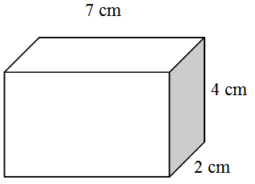](http://websites.pdesas.org/sethtriggs/2010/5/27/45174/file.aspx)Find the volume of the rectangular prism: