Math 6 Unit 5: Area and Volume Study Guide Name ______________________________ Per._____
3/4 in.
- Determine the VOLUME and the SURFACE AREA of
the cube pictured at right.

- Find the area of the shaded section of the square below.
8 m

- Find the area of the triangle pictured below.
9 ¼ cm
10 cm
13 cm
7.5 cm

- The dimensions for two boxes ae shown in the table.
Dimensions | Box A | Box B
Height | 8.5 | 10
Width | 2 | 1.8
Length | 4.8 | 5

Which box has a greater volume? _____________ By how much? ___________

- Determine the area of the trapezoid.
2 cm
2 cm
36 cm
16 cm
- Find the area of the composite figure shown below.
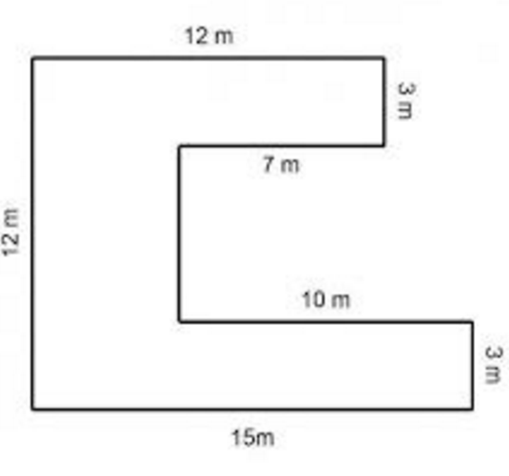

- What is the difference between AREA and SURFACE AREA?

- What is the difference between SURFACE AREA and VOLUME?

- Determine the surface area of a rectangular prism with a length of 7 cm, a width of 6 cm, and a height of 4 cm. Use the pictures if need to help you solve.
SA = ______________

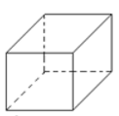
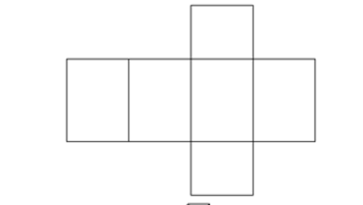

- If sod grass can be purchased at $0.50 per square foot, how much would it cost to put sod in a backyard shaped like a rectangle that is 15 feet wide and 25 feet long?

- How many square centimeters of wrapping paper are needed to cover the surface area of the box shown to the right?

- The volume of a rectangular prism can be found by using the formula V = Bh, where B is the area of the base. If the base of a prism is square with a side length of 4 inches and the height of the prism is inches, find the volume of the prism.

- What is the surface area of the square pyramid shown?
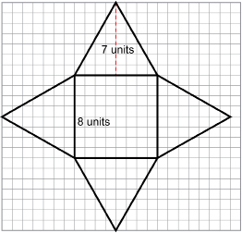

- A rectangular prism is filled with small cubes of the same size. The bottom layer consists of 6 cubes, each with a volume of 1 cubic cm. If there are 3 layers of cubes in the prism, what is the volume of the rectangular prism?

Volume = _________________________

- Find the area of the non-shaded region.
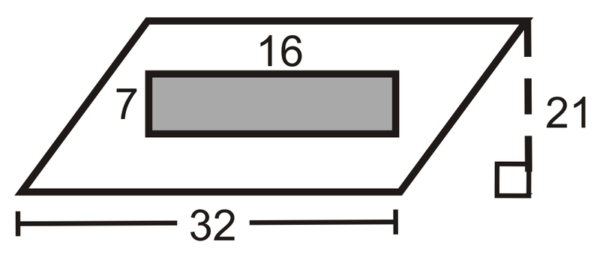

- Find the area of the shaded pentagon.

4yd 4in

4in

3yd
18 yd
5yd

- Mary wants to carpet a portion of her rectangular room. She wants to leave the two congruent triangles bare wood without carpet. Each of the triangles has a base of 8 feet and a height of 12 feet. What is the area of the carpeted flooring she will need?
Area = _____________________
40 feet

17 feet

