Unit 2: Ratios and Proportional Reasoning Name ________________P __
Study Guide
1. Write an equivalent ratio to 2:3. _____________

2. The ratio of boys to girls in a class is 3:4. If there are 42 students in the class, how many are boys? ______

3. Write the rate as a unit rate: $48 for 4 tickets. _______

4. Joe drove 215 miles in 3 hours. Moe drove 240 miles in 4 hours. Who drove at the fastest rate of speed? _______
How fast was each person driving? Joe_______________ Moe ________________

5. Each table below represents a proportional relationship. Complete the tables by filling in the missing values.
x | y
2 | 3
 | 6
6
 | 12
 | 15
x | y
1 | 5
 | 25
6
30
 | 225
x | y
3
21 | 28
6
 | 16
9
x | y
2 | 7
8
12
 | 56
 | 63

6,. The prices of 4 different bottles of shampoo are given in the table. Which bottle size is the best value? ________
Size | Price
24 oz. | $450
15 oz | $2.30
8 oz. | $1.60
4 oz. | $0.95

7. Determine the missing value. $\frac{16}{20}= \frac{x}{180}$

8. The table below shows the number of each item sold at the concession stand. What might the ratio 3:2 represent?
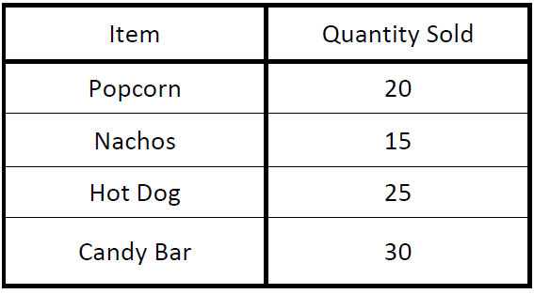

9. Using the same table above, what is the ratio of hot dogs to popcorn? _________

10. What is the ratio of Nachos to all food items? __________

Use the double number line below to answer questions 15-18.
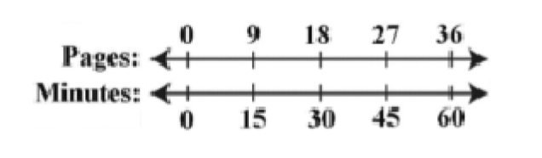
11. How long will it take to read 27 pages? _________

12. How many pages can be read in 15 minutes? _________

13. How long will it take to read 90 pages? _________

14. How many pages can be read in 2 hours? _________

15. The table below shows the cost of varying number of books. If the relationship stays the same, determine the value of n.

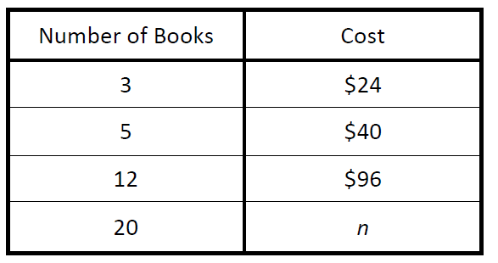

16. The graph below compares cups to pints. Which of the following ordered pairs would also satisfy this relationship?
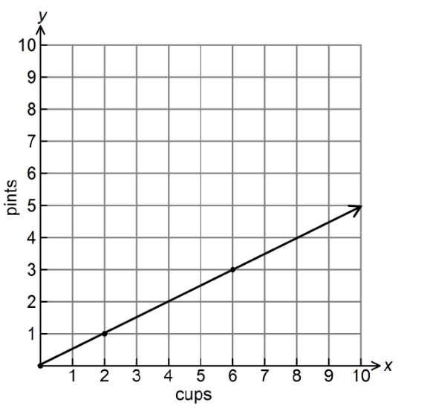
- (4, 2) B. (2,4) C. (2,0) D. (1,2)

17. Thirteen is 25% of what number? _____________

18. Find 15% of 32. ______________

19. If in a class of 40 students, 45% are in Band, how many students are in Band?

20. Ann deposits 20% of her earning each week into her savings account. If she deposited $17 this week, how much did she earn? __________

21. If 1 inch is approximately 2.54 centimeters, about how many centimeters are equal in length to 1 foot? _______

