Math 6 Practice Milestones Assessment ~ Units 1-7
- Which is the greatest common factor of 20 and 36?
- 2
- 4
- 12
- 180
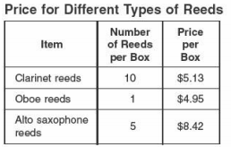

Based on this table, what is the cost to buy 10 of each different type of reed?

- $18.50
- $26.92
- $71.47
- $98.35

- The table shows the names and times of the first-place swimmer and second-place swimmer in the men’s 100 meter backstroke.
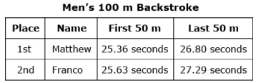

The total time for each swimmer is the sum of the two parts. How much faster did the first-place swimmer swim than the second-place swimmer?

- 0.24 seconds
- 0.66 seconds
- 0.76 seconds
- 0.84 seconds
- A truck driver drove 5,680 miles last year. She took a total of 20 trips. What is the average length, in miles, of one of her trips?

- 234
- 284
- 5,660
- 5,700

- Which expression correctly uses the distributive property to rewrite the expression 7(y + 5)?
- 7y + 5
- 5(7 + y)
- 7y + 35
- 12(7 + y)

- If m = 3, what is the value of the expression: (6 + m) ÷ 2 + 3² - m

- 7
- 10
- 10.5
- 9.5

- Mason has been to the dentist at least 15 times in his life. Which inequality represents this situation?

- d > 15
- d > 15
- d < 15
- d < 15

- Ms. Randall bought a large fish tank for her classroom. What is the volume of her new tank?

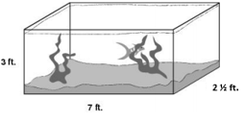
- 12 ½ feet³
- 52 ½ feet³
- 60 feet³
- 105 feet³

- At a wedding reception attended by 200 people, the youngest person was 2 years old, and the range of ages was 94 years. How old was the oldest person at the reception?

- 92
- 96
- 94
- 200
- The box and whisker plot shown below represents the heights, in inches, of the members of the Central High School Girls’ basketball team. What is the interquartile range (IQR) of the team members?
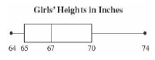

- 5 inches
- 10 inches
- 67 inches
- 68 inches

- Daisha is buying packs of pencils and erasers. Pencils come in packs of 12, and erasers come in packs of 20. If she wants to have an equal number of pencils and erasers, what is the minimum number of each that she could buy?

- 4 packs of pencils and 3 packs of erasers
- 4 packs of pencils and 5 packs of erasers
- 5 packs of pencils and 3 packs of erasers
- 10 packs of pencils and 6 packs of erasers

- Jeanette’s car uses 15 gallons of gas for every 360 miles she drives. How far can Jeanette’s car drive with 6 gallons of gas?

- 17 miles B. 144 miles C. 72 miles D. 25 miles

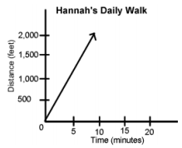

The graph above shows the time it took Hannah to walk a certain distance. What was Hannah’s
constant of variation?
- 100 feet per minute
- 200 feet per minute
- 500 feet per minute
- 1000 feet per minute
- In a town, a middle school has 45 classrooms. This amount is 30% of all the classrooms in the entire town. How many total classrooms are in the town?

- 67
- 75
- 135
- 150

- Jerry had k pencils. Darcy and Leonard then gave Jerry an additional x pencils each. Which expression could represent the number of pencils Jerry has now?

- k + x
- k + 2x
- 2k + x
- 2(k + x)

- Bella and Kobe were both trying to solve the equation 4x = 12. Bella multiplied both sides of the equation by 3. Kobe divided both sides of the equation by 4.

Part A: Who solved the equation correctly?

Part B: What is the correct value(s) for the variable x?

- Zahra needs to paint the top, bottom and the sides of a treasure chest box. The dimensions of the chest box are shown in inches. How much paint will Zahra need to paint her treasure chest box?

- 326 in.²
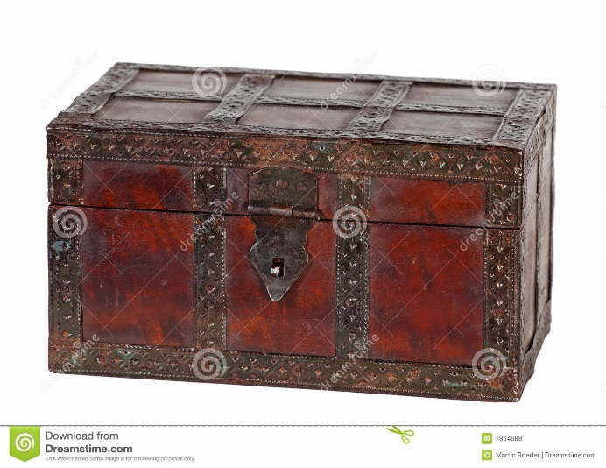
- 524 in.²
13 in.
8 in.
10 in.
- 628 in.²
- 1,040 in.²

- The side view of a wall is shown below. What is the area of the wall?
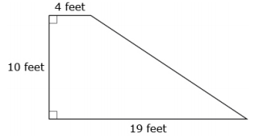
- 33 square feet
- 115 square feet
- 150 square feet
- 190 square feet

- Alice works in the career center at her school and is recording how many people visit each day while she’s there. The table shows her data for 6 days.
Day | 1 | 2 | 3 | 4 | 5 | 6
Number of People | 11 | 18 | 15 | 12 | 14 | 11

What is the median number of people who visited the career center?
- 11 people
- 12 people
- 13 people
- 14 people

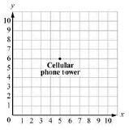
- The location of a cellular phone tower is shown on this coordinate plane.

Each unit on the graph represents 0.5 mile. The phone company is building another tower 2.5 miles
away. At which point could the new cellular phone tower be located?
- (0,6)
- (1.6)
- (6,5)
- (5,3)

- If a point has a negative x coordinate and a negative y coordinate, what quadrant is it located in?

- Quadrant I
- Quadrant II
- Quadrant III
- Quadrant IV

- Which choice lists the numbers in order from least to greatest?
- $\frac{1}{2}, 0.25, \frac{1}{ 6}, 1.0$
- $1.0, \frac{1}{2}, 0.25, \frac{1}{6}$
- $\frac{1}{6}, 0.25, \frac{1}{2}, 1.0$
- $\frac{1}{6}, \frac{1}{2}, 0.25, 1.0$
- Chi graphed a rectangle with a vertex in each quadrant of the coordinate plane. Three of the vertices are located at (3,2), (3,-11), and (-4,-11). Which ordered pair completes the rectangle?

- (3,-2)
- (-4-11)
- (-11,2)
- (-4,2)

- Part A: Simplify the expression $15 (\frac{1}{3}+\frac{2}{5})$

- 5 + 6
- $15(\frac{10}{15})$
- $15\frac{1}{3}+\frac{2}{5}$
- $90+15$

Part B: Which property was use?

- Associative property of multiplication
- Commutative property of multiplication
- Distributive property
- Multiplicative identity property
Constructed Response

- A baker used the expression 6(15 + y) to show the number of muffins he needed to make based on y, the number of orders placed.
Part A: Emily said the expression 90 + y has the same value as 6(15 + y). Is Emily correct? Tell which property of operation she used.

Part B: What is the value of the expression 6(15 + y) when y = 3?

Part C: The numbers of muffins the baker made on 6 days are listed below.
150, 162, 174, 150, 186, 198
Based on this information, what is the mean number of muffins the baker made per day? Explain how you find the mean.

- Merida has 24 flowers. Each flower is either pink or white.
Part A: If the ratio of pink to white flowers is 5 to 3, how many flowers of each color does Merida
have?

Part B: Merida wrote the expression 3 • 2³ to represent the number of the flowers she
gave to her friends. Write an expression, using repeated multiplication, equivalent to Merida’s expression.

Part C: Merida wrote the equation f + f + f + f + f + f = 24 to represent the number of flowers she
gave to her friends. Is 8 a solution for Merida’s equation? Explain your answer.

