Name: ____________________________________________ Date: _________________ __________ Period: ______

1. Identify the interquartile range from the box plot below.

A. 35

B. 25

C. 20

D. 5

5

10

15

20

25

30

35

40

45

1. The line plot below shows the number of miles swam by each member of the swim team. What is the **total** distance the swim team swam?

|  |  |  |  |  |
| --- | --- | --- | --- | --- |
|  | X  X | X  X  X | X  X  X  X | X |
| 0 |  |  |  | 1 |

Miles

|  |  |  |  |  |  |  |  |
| --- | --- | --- | --- | --- | --- | --- | --- |
| A. | 6 miles | B. | 5 miles | C. | miles | D. | miles |

1. Amanda’s test scores are 85, 93, 84, and 88. What does she need to score on the next test for her test average to be a 90?

|  |  |
| --- | --- |
| A. | 93 |
| B. | 95 |
| C. | 97 |
| D. | 100 |
|  |  |

1. Zeke is surveying his classmates on the number of times they have visited Disney World. He says this is a statistical question.

A. True B. False

1. The ARC Trucking Company keeps records of the weekly distances driven by each of its drivers. The distances driven by Conrad during the last 4 weeks are shown in the table. Which measure of the data would NOT be a good predictor of the number of miles that Conrad might drive next week?

|  |  |
| --- | --- |
| Week 1 | 2,895 |
| Week 2 | 2,895 |
| Week 3 | 2,964 |
| Week 4 | 2,762 |

|  |  |  |  |  |  |  |  |
| --- | --- | --- | --- | --- | --- | --- | --- |
| A. | mean | B. | median | C. | mode | D. | range |

6. The following table shows the number of pages in novels that Kelly read for pleasure each month during the

school year. If Kelly only read 125 pages during the month of May, which measure of data changed the most?

|  |  |  |  |  |  |  |  |  |
| --- | --- | --- | --- | --- | --- | --- | --- | --- |
| Month | Sept. | Oct. | Nov. | Dec. | Jan. | Feb. | Mar. | Apr. |
| Number of Pages | 370 | 393 | 380 | 376 | 396 | 372 | 385 | 391 |

|  |  |
| --- | --- |
|  |  |

A. mean B. median C. mode D. All measures affected equally.

7. The hourly wages for seven workers are: $5, $12, $13, $10, $6, $5, $12. Determine the mean of the data to the nearest cent.

|  |  |  |  |
| --- | --- | --- | --- |
| A. | $10.50 | C. | $9.00 |
| B. | $9.50 | D. | $7.00 |

8. A measure of ________ for a **numerical** data set summarizes all of its values with a single number.

A. shape B. graph C. symmetry D. center

9. Megan was curious and wanted to know the ages of the people sitting near her at Chick-fil-A. To earn extra credit, she created the dot plot below.

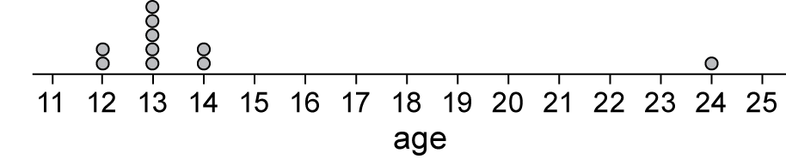

Which best describes the center of the data?

A. mean B. median C. interquartile range D. range

10. Kellen recorded the grades of the students in his science class’s test scores and created the stem-and-leaf plot below.

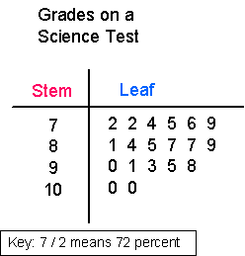

Which measure of **variation** best describes the stem and leaf graph above?

A. interquartile range B. mean C. median D. not listed

11. If you have a **gap** in a data set, what does that represent?

A. The value is much higher or lower than the other data values

B. No data for a particular value

C. A cluster of data

D. The difference of the maximum and minimum values.

12. If you drew an example of a data set that is **skewed right** on a graph**,** which of the following is TRUE

A. Most of the data will be on the left

B. All the data will be symmetrical

C. Most of the data will be on the right

D. The graph will have a bell curve shape

13. What percent of the data can be represented by the Interquartile Range?

A. 5% B. 75% C. 25% D. 50%

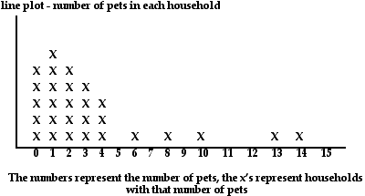

14. What measure of center best represents the data and why?

A. Mean because you can just ignore the data on 6, 8, 10, 13, & 14 and say the data is symmetrical.

B. Mean or median because the data is symmetrical

C. Median because the data is skewed right

D. Range because all the data falls between 0 and 14

15. Using the histogram below, what is the frequency of calculators that cost $20-$39?

A. 10 B. 12 C. 11 D. Not enough information to determine.

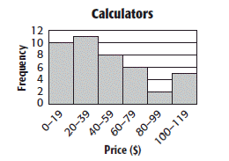

16. Explain what an outlier does to the mean of a data set.

1. It will skew the mean of the data set
2. It will skew the median of the data set.
3. It will make the range smaller.
4. It will make the graph symmetrical.

Key

