Unit 6 Statistics Name ___________________________________

- (3 pts) Explain what an outlier is in statistics.

- (4 pts) Find the mean, median, and mode for the following data: 8, 4, 3, 7, 6, 11.

Mean: ______
Median: ______
Mode: ______
Range: _____

- (6 pts) Organize the data below into a stem and leaf plot.
Science test scores: 95, 82, 90, 55, 79, 83, 89, 75, 77, 84, 88

What is the range of the data? _______ What does it tell you about this data set? _____________________________________________________________________________________

- (2 pts) The Unit 5 Project grades are posted. All students scored over 80%. Unfortunately, 2 students did not complete the assignment and received a zero. What measure of center would give the best representation of the students’ understanding of Unit 5? _______________________________________________

- (6 pts) Use the following data to create a box & whisker plot:
Age of students that downloaded “The Hunger Games” at Fiction Secondary School
12 12 15 16 17 16 15 13 11
15 16 16 15 13 13 14 15 18

Identify:
Minimum:____
Maximum:____
Median:____
Lower Quartile:____
Upper Quartile:_____
Interquartile Range:_____

- (6 pts) Use the following data to create a histogram:
Number of Text Messages per Minute
6 8 4 1 10 3 12 5 3
5 2 0 2 3 3 2 1 2

Pull ups completed by students during a fitness test
3 3 10 1 0 2
3 7 0 12 2 5
0 2 8 10 11 2

- (6 pts) Create a dot/line plot of the following data:

Multiple Choice/Short Answer – 3 points each

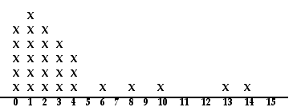
Number of Pets in Household

Which measure of center, the mean or the median, better shows the typical number of pets in each household? Explain why. _________________________________________________________________
_________________________________________________________________________________________

- Which measure, the range or the interquartile range, is MOST affected by outliers? _________________________

- Ten students were surveyed to find out how much weekly allowance they received. The following data was collected: $5, $5, $7.50, $10, $10, $10, $15, $15, $20, $25. Which measure of center would be most appropriate to describe the typical allowance for this group of students? Justify your reasoning. ______________________
__________________________________________________________________________________________________________

- Identify the interquartile range from the box plot below.

15 20 25 30 35 40 45 50 55

A. | 35 | B. | 25 | C. | 20 | D. | 5

- The line plot below shows the number of miles swam by each member of the swim team.
 | X  X | X  X  X | X  X  X  X | X
0 | 1 | 2 | 3 | 4
Miles

What is the total distance the swim team swam?
A. | 6 miles | B. | 10 miles | C. | 24 miles | D. | 16 miles

- Ed’s test scores are 85, 93, 84, and 88. What does he need to score on the next test for his test average to be a 90?
A. 93 B. 95 C. 97 D. 100

- Which of the following is FALSE?
A. | Statistical questions can generate numerical or categorical data.
B. | Statistical questions have a variety of answers.
C. | “Do you exercise?” is an example of a statistical question.
D. | Whether or not a question is statistical or not may depend on the group or population being asked..

- The ARC Trucking Company keeps records of the weekly distances driven by each of its drivers. The distances driven by Conrad during the last 4 weeks are shown in the table.
Week 1 | 2,895
Week 2 | 2,895
Week 3 | 2,964
Week 4 | 2,762

Which measure of the data would NOT be a good predictor of the number of miles that he might drive next week?
A. | mean | B. | median | C. | mode | D. | range

- The following table shows the number of pages that Kelly read each month during the school year.
Month | Sept. | Oct. | Nov. | Dec. | Jan. | Feb. | Mar. | Apr.
Number of Pages | 370 | 393 | 380 | 376 | 396 | 372 | 385 | 391

If Kelly only read 50 pages during the month of May, which measure of data would change the most?
A. mean B. median C. mode D. All measures were affected equally
- The hourly wages for seven workers are: $8, $20, $20, $18, $16, $15, $13 , $10. Determine the mean absolute deviation of the data.
A. $4.00 B. $3.50 C. $15 D. $28

- Which of the following best describes the shape and distribution of the box plot shown below?

  - The data is equally distributed among the four quartiles.
  - There is a cluster of data in quartile 3.
  - There is more data in quartiles 3 and 4 than in quartiles 1 and 2.
  - There is more spread in data values in quartiles 3 and 4 than in quartiles 1 and 2.

- (4 pts) Match the plot/graph with its description.
Table | Description
_______Histogram | - Best used to see the overall spread of large data sets.
_______Stem and Leaf Plot | - Good to see the individual data values in a data set arranged by place value.
________Box Plot | - Best for organizing smaller sets of data with each data value shown on a number line.
________Line or Dot Plot | - Best for grouping and comparing data into equal intervals.
____________________________________________________________________________________________
Problem | Standard | Answer
 | MCC.6.SP.3 | A outlier is a data value that much higher or lower that the rest of the data in the set. It skews the mean.
 | MCC6.SP.5.c | Mean=6.5  Median=6.5  Mode=no mode  Range = 8
 | MCC6.SP.5.c | 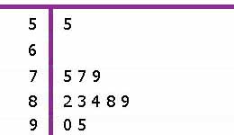  Stems Leaves  Key: 5|5 means 55  Science Test Scores  The range is 40. There is 40 points from the lowest score to the highest score.
 | MCC6.SP.5.d | Median because an outlier exists.
 | MCC6.SP.4 | 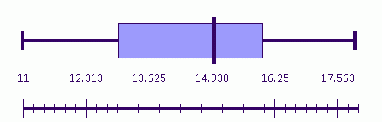  Minimum: 11  Maximum: 18  Median: 15  Lower Quartile: 13  Upper Quartile: 16  Interquartile Range: 3
 | MCC6.SP.4 | Results will vary.  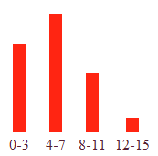
 | MCC6.SP.4 | x  x x x  x x x x  x x x x x x x x x x  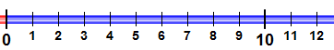
 |  | C
 | MCC6.SP.5.d | The shape is skewed left with data mostly from 0-4; the mean is affected by outliers; the median is not affected by outliers-so the median would describe the data better.
 |  | Range
 | MCC6.SP.5 | Since there are no outliers, mean would be best.
 | MCC6.SP.5 | B
 | MCC6.SP.4 | C
 | MCC6.SP.5 | D
 | MCC6.SP.1 | C
 | MCC6.SP.5 | D
 | MCC6.SP.2 | A
 | MCC6.SP.5 | B
 | MCC6.SP.5 | D
 |  | DBAC

